**Project Design Phase**

**Solution Architecture**

|  |  |
| --- | --- |
| Date | 23 March 2025 |
| Team ID | PNT2025TMID06680 |
| Project Name | **Global Food Production Trends and Analysis A Comprehensive Study from 1961 to 2023 Using Power BI** |
| Maximum Marks | 4 Marks |

**Solution Architecture:**

The solution architecture for **Global Food Production Trends and Analysis** integrates historical and real-time data from sources like FAO, IoT sensors, and weather APIs. Data is ingested, cleaned, and processed using AI/ML models for predictive analytics and anomaly detection. Power BI dashboards provide dynamic visualizations, enabling researchers, policymakers, and agribusinesses to make data-driven decisions.

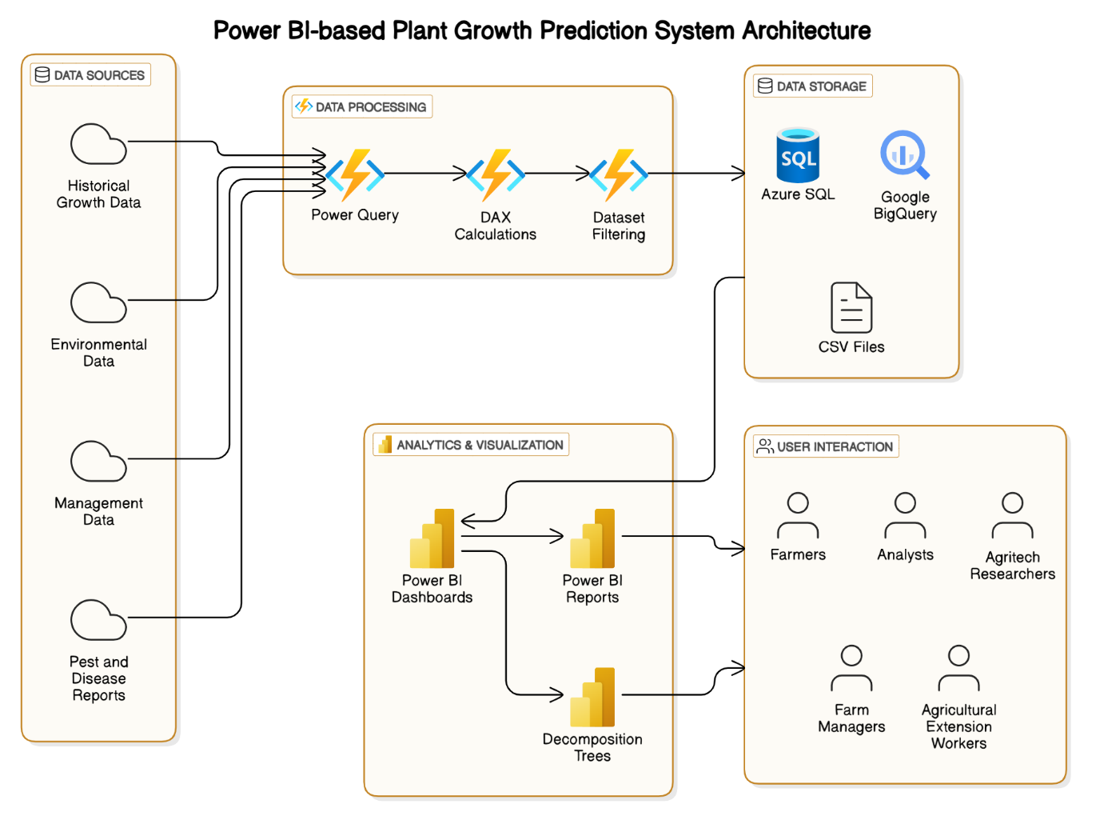**Example - Solution Architecture Diagram:**

*Figure 1: Architecture and data flow of the voice patient diary sample application*